CCT COLLEGE DUBLIN

Big Data - Large-Scale Data Handling for Ireflix

Student Full Name | Arkadiusz Jedrzejewski
Student Number | sba25006
Module Title | Big Data Analytical Methods
Assessment Tittle | Large-Scale Data Handling for Ireflix
Lecturer / Supervisor | Dr. Kislay Raj and Dr. Muhammad Iqbal
Assessment Due Date | Sunday 31st May 2026
Date of Submission | Saturday 30rd May 2026

Use of AI Tools
AI tools were used in the preparation of this assessment in the following ways:
1. Synthetic data generation (Jupyter Notebook — synthetic_data_generation.ipynb) AI was used to generate the complete Python code for synthetic data generation, including all seven datasets: Users, Movies, Series, Actors, Directors, UserMovies and UserSeries, using the Faker library with Irish locale (en_IE).
2. SQL revenue column (CA1.sql) AI was used to generate a short SQL script to add a revenue column to the Movies table and populate it with approximated values calculated as ROUND(rating * 50000000), as noted in the comment on line 266: "APPENDIX - AI generated Revenue".
All AI-generated code was reviewed, tested and understood by the author before submission. AI was not used in the writing of the report, the database design, the SQL queries, or the MapReduce section of this assessment.
Declaration
By submitting this assessment, I confirm that I have read the CCT policy on academic misconduct and understand the implications of submitting work that is not my own or does not appropriately reference material taken from a third party or other source.
I declare it to be my own work and that all material from third parties has been appropriately referenced.
I further confirm that this work has not previously been submitted for assessment by myself or someone else in CCT College Dublin or any other higher education institution.

CA1 – Big Data and Legacy Systems - REPORT

- Big Data and the 3 Vs
The term "Big Data" has become a symbol of automation and efficient processing of large volumes of data, which represent both a challenge and a significant source of value for modern businesses and institutions. When we think about Big Data, we imagine an extraordinarily large database containing all kinds of information, which may be stored in a more or less organised and structured way.
There is no single universally accepted definition of Big Data; however, one definition proposed by IBM particularly stood out to me.
"Big data refers to massive, complex datasets that traditional data management systems cannot handle" (IBM, 2025).

This term is characterised by specific properties that allow us to better understand what a given dataset is and how it should be managed. It is worth noting that I have come across two approaches to defining Big Data: the 3V model and the 5V model. We will focus on the first approach in a moment, but it is useful to know that the 5V concept goes beyond viewing data as simply a collection of raw data, and in an extended way adds two additional factors: Veracity and Value.
However, we focus on the 3 core terms that are most relevant in the context of Big Data. Volume refers to the quantity of data we hold; in our case of Ireflix, this means millions of user records, viewing histories and metadata. Velocity describes how quickly data can be produced and generated, and how fast we are able to process it on a streaming platform. Variety reflects how diverse the data is, from structured SQL tables, through semi-structured logs, to completely unstructured data such as user ratings and reviews

The three dimensions of Big Data were first visualised by Laney (2001) as shown in Figure 1 below.

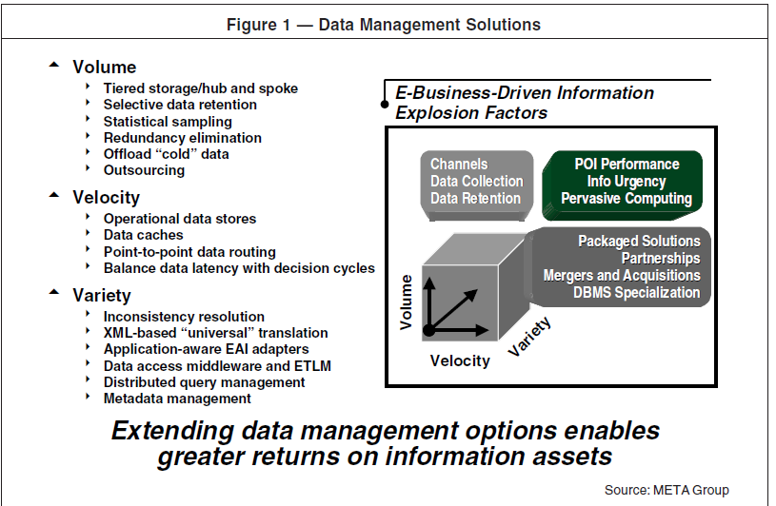
Figure 1: Data Management Solutions — the original 3V framework.

In the case of Ireflix, we can expect to deal with large volume, where millions of target users will be watching hundreds or even thousands of movies and series available on the platform, and in the future possibly applications and games as well. Velocity may be greater than we think, as it will be generated in relation to all user activity on the platform. Variety will be reflected in every type of data, from structured SQL tables, through metadata and logs, to completely unstructured data such as ratings.

- Big Data Challenges for Ireflix at 50 Million Users
The first challenge will be the legal framework. If we assume that we are an Irish company, we need to take into account both local law and European Union law, which sets the boundaries for how we operate and process our databases. In this context, we will be operating within the scope of GDPR, enforced in Ireland by the Data Protection Commission. Every user record must be stored lawfully, with clear consent mechanisms and the right to erasure implemented at the appropriate moment, for example upon a direct request from the user.
For Ireflix, database architecture must be designed with technical complexity to address an already large-scale data management challenge. Our data will rely on machine learning algorithms to power content recommendation systems; it must also comply with the EU Artificial Intelligence Act (2024), which requires transparency, human oversight, and documented risk assessments.
The second challenge may be Volume, or more precisely, how we will store the constantly growing database of our tables and data relating to movies and logs, as petabytes of new data will accumulate exponentially. The question is whether we will need to invest in our own infrastructure, sign agreements with major players and use AWS or Azure, or whether a hybrid solution in the context of GDPR and AI regulations will require broader analysis, and this ties directly into the problem of scalability.
- Horizontal versus Vertical Scaling
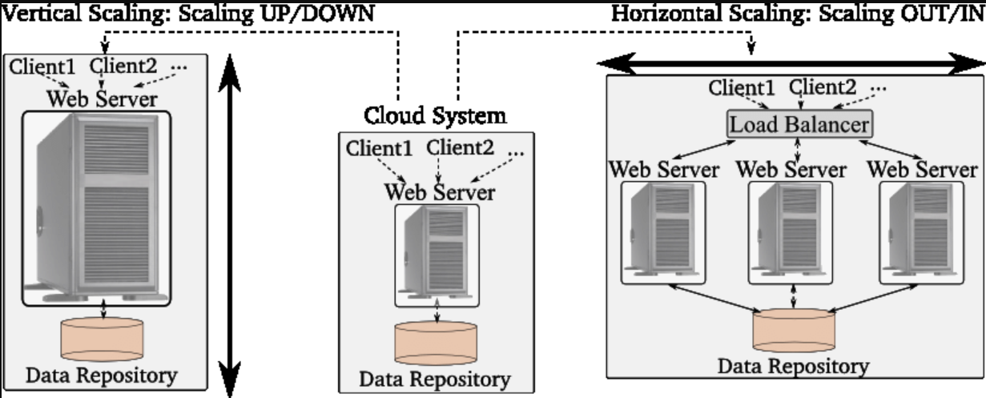
Figure 2: Vertical vs. Horizontal Scaling.

Vertical scaling involves expanding an existing server by adding more RAM, processing power or larger storage drives. It is a straightforward and quick solution, but it has its limitations. At a certain point, it is no longer possible to upgrade a single machine further, and on top of that, if that one server goes down, the entire platform stops working.
Horizontal scaling works oppositely. Instead of upgrading a single server, we add more machines and distribute the load across them. Hardware can be added and removed flexibly depending on current demand.
For Ireflix, horizontal scaling is the right choice. The platform is starting in Ireland but is aiming for global expansion, just like its competitors, which means we need to be ready for unpredictable spikes in data processing, for example during major new title releases. We can still debate which exact direction to take, but adding new machines alongside a partial hybrid cloud infrastructure seems like a sensible path forward — keeping sensitive data on local servers while moving the rest to the cloud, giving us the scalability we need as we grow.

- Real-World Organisations Using Big Data

Pfizer is the world's largest pharmaceutical company and a clear example that Big Data touches every area of human life. In 2019, Pfizer, together with Amazon Web Services, built what is known as the Scientific Data Cloud, a kind of central portal that collects data from hundreds of laboratories and allows scientists to search through historical molecular data in real time. For the analysis of clinical trial data, the company uses AWS, Snowflake and Fivetran.
The company's goal is to shorten the processing of clinical trials and accelerate the journey from molecule discovery to drug registration. A central platform of this kind is a very effective solution that Ireflix could look to adopt in its own data architecture.
Who among us has never called a taxi? Uber operates in over 70 countries and every day processes trillions of messages generated by the driver and passenger layers of its application. The heart of its infrastructure is Apache Kafka, which collects data in real time and passes it to Apache Flink, where it is processed instantly. The most well-known example of this in action is surge pricing, a system that calculates the dynamic price of a ride within seconds based on the current supply of drivers and demand from passengers in a given area.
TikTok is a platform with over one billion active users and processes petabytes of user data daily. For processing historical batch data, it uses Apache Spark, and for real-time streaming it relies on Apache Flink. The recommendation model updates within seconds of each user interaction. It is precisely this mechanism, known as the #For You Page, that is responsible for the remarkable level of user engagement on the platform.
Ireflix could adopt a similar approach by capturing signals from the UserMovies and UserSeries tables and using them to continuously fine-tune content recommendations for each user.

- References
IBM (2025) What are big data use cases? Available at: https://www.ibm.com/think/topics/big-data-use-cases (Accessed: 28 May 2026).
Sharma, P. (2021) 'Big Data — 3 V's and 5 V's', Analytics Vidhya, Medium. Available at: https://medium.com/analytics-vidhya/big-data-3-vs-and-5-v-s-c1cae2a6d311 (Accessed: 28 May 2026).
Laney, D. (2001) 3D Data Management: Controlling Data Volume, Velocity, and Variety. META Group, File 949, 6 February. Available at: https://www.academia.edu/37216189/Application_Delivery_Strategies (Accessed: 23 May 2026).
Data Protection Commission (2024) Data Protection Legislation. Available at: https://www.dataprotection.ie/en/who-we-are/data-protection-legislation (Accessed: 28 May 2026).
European Parliament (2024) Regulation (EU) 2024/1689 — Artificial Intelligence Act. Official Journal of the European Union. Available at: https://eur-lex.europa.eu/legal-content/EN/TXT/?uri=CELEX:32024R1689 (Accessed: 25 May 2026).
Microsoft (2024) What is Azure? Microsoft Azure. Available at: https://azure.microsoft.com/en-us/resources/cloud-computing-dictionary/what-is-azure/ (Accessed: 25 May 2026).
Moldovan, D. (2015) On Monitoring and Analyzing Elastic Cloud Systems. Doctoral dissertation. Vienna: Technische Universität Wien (TU Wien). Available at: https://www.researchgate.net/figure/ertical-Vs-Horizontal-scaling_fig3_293799134 (Accessed: 25 May 2026).
Drug Discovery Trends (2023) Pfizer exec frames digital as a core business strategy. Available at: https://www.drugdiscoverytrends.com/pfizer-exec-frames-digital-as-a-core-business-strategy/ (Accessed: 26 May 2026).
Uber Engineering (2022) Disaster recovery for multi-region Kafka at Uber. Available at: https://www.uber.com/us/en/blog/kafka/ (Accessed: 27 May 2026).
Uber (2024) How surge pricing works. Available at: https://www.uber.com/us/en/drive/driver-app/how-surge-works/ (Accessed: 27 May 2026).
La Vivien Post (2025) TikTok system design — architecture illustrated. Available at: https://www.lavivienpost.com/how-tiktok-works-architecture-illustrated/ (Accessed: 28 May 2026).
TikTok (2023) How TikTok recommends videos for you. TikTok Newsroom. Available at: https://newsroom.tiktok.com/en-us/how-tiktok-recommends-videos-for-you (Accessed: 28 May 2026).

IBM (2025) What are big data use cases? Available at: https://www.ibm.com/think/topics/big-data-use-cases (Accessed: 23 May 2026).
Sharma, P. (2021) Big Data — 3 V's and 5 V's. Analytics Vidhya, Medium. Available at: https://medium.com/analytics-vidhya/big-data-3-vs-and-5-v-s-c1cae2a6d311 (Accessed: 28 May 2026).
Laney, D. (2001) 3D Data Management: Controlling Data Volume, Velocity, and Variety. META Group, File 949, 6 February. Available at: https://www.academia.edu/37216189/Application_Delivery_Strategies (Accessed: 23 May 2026).
Data Protection Commission (2024) Data Protection Legislation. Available at: https://www.dataprotection.ie/en/who-we-are/data-protection-legislation (Accessed: 23 and 28 May 2026).
European Parliament (2024) Regulation (EU) 2024/1689 — Artificial Intelligence Act. Official Journal of the European Union. Available at: https://eur-lex.europa.eu/legal-content/EN/TXT/?uri=CELEX:32024R1689 (Accessed: 25 May 2026).
Microsoft (2024) What is Azure? Microsoft Azure. Available at: https://azure.microsoft.com/en-us/resources/cloud-computing-dictionary/what-is-azure/ (Accessed: 25 May 2026).
Moldovan, D. (2015) On Monitoring and Analyzing Elastic Cloud Systems. Doctoral dissertation. Vienna: Technische Universität Wien (TU Wien). Available at: https://www.researchgate.net/figure/ertical-Vs-Horizontal-scaling_fig3_293799134 (Accessed: 25 May 2026).
Drug Discovery Trends (2023) Pfizer exec frames digital as a core business strategy. Available at: https://www.drugdiscoverytrends.com/pfizer-exec-frames-digital-as-a-core-business-strategy/ (Accessed: 26 May 2026).
Uber Engineering (2022) Disaster recovery for multi-region Kafka at Uber. Available at: https://www.uber.com/us/en/blog/kafka/ (Accessed: 27 May 2026).
Uber (2024) How surge pricing works. Available at: https://www.uber.com/us/en/drive/driver-app/how-surge-works/ (Accessed: 27 May 2026).
La Vivien Post (2025) TikTok system design — architecture illustrated. Available at: https://www.lavivienpost.com/how-tiktok-works-architecture-illustrated/ (Accessed: 28 May 2026).
TikTok (2023) How TikTok recommends videos for you. TikTok Newsroom. Available at: https://newsroom.tiktok.com/en-us/how-tiktok-recommends-videos-for-you (Accessed: 28 May 2026).

